This page intentionally left blank

13

FINANCIAL SECTION

14

This page intentionally left blank

15

INDEPENDENT AUDITORS’

REPORT

16



INDEPENDENT AUDITOR’S REPORT

To the City Council

City of Clayton, California

Report on the Audit of the Financial Statements

Opinions

We have audited the accompanying financial statements of the governmental activities, the business-type activities, each major fund, and the aggregate remaining fund information of the City of Clayton, Clayton, as of and for the year ended June 30, 2022, and the related notes to the financial statements, which collectively comprise the City of Clayton’s basic financial statements as listed in the table of contents.

In our opinion, the financial statements referred to above present fairly, in all material respects, the respective financial position of the governmental activities, the business-type activities, each major fund, and the aggregate remaining fund information of the City of Clayton, as of June 30, 2022, and the respective changes in financial position, and, where applicable, cash flows thereof for the year then ended in accordance with accounting principles generally accepted in the United States of America.

Basis for Opinions

We conducted our audit in accordance with auditing standards generally accepted in the United States of America and the standards applicable to financial audits contained in Government Auditing Standards, issued by the Comptroller General of the United States. Our responsibilities under those standards are further described in the Auditor’s Responsibilities for the Audit of the Financial Statements section of our report. We are required to be independent of the City of Clayton and to meet our other ethical responsibilities, in accordance with the relevant ethical requirements relating to our audit. We believe that the audit evidence we have obtained is sufficient and appropriate to provide a basis for our audit opinions.

Responsibilities of Management for the Financial Statements

Management is responsible for the preparation and fair presentation of the financial statements in accordance with accounting principles generally accepted in the United States of America, and for the design, implementation, and maintenance of internal control relevant to the preparation and fair presentation of financial statements that are free from material misstatement, whether due to fraud or error.

In preparing the financial statements, management is required to evaluate whether there are conditions or events, considered in the aggregate, that raise substantial doubt about the City of Clayton’s ability to continue as a going concern for twelve months beyond the financial statement date, including any currently known information that may raise substantial doubt shortly thereafter.

Auditor’s Responsibilities for the Audit of the Financial Statements

Our objectives are to obtain reasonable assurance about whether the financial statements as a whole are free from material misstatement, whether due to fraud or error, and to issue an auditor’s report that includes our opinions. Reasonable assurance is a high level of assurance but is not absolute assurance and therefore is not a guarantee that an audit conducted in accordance with generally accepted auditing standards and Government Auditing Standards will always detect a material misstatement when it exists. The risk of not detecting a material misstatement resulting from fraud is higher than for one resulting

17

from error, as fraud may involve collusion, forgery, intentional omissions, misrepresentations, or the override of internal control. Misstatements are considered material if there is a substantial likelihood that, individually or in the aggregate, they would influence the judgment made by a reasonable user based on the financial statements.

In performing an audit in accordance with generally accepted auditing standards and Government Auditing Standards, we:

Exercise professional judgment and maintain professional skepticism throughout the audit.

Identify and assess the risks of material misstatement of the financial statements, whether due to fraud or error, and design and perform audit procedures responsive to those risks. Such procedures include examining, on a test basis, evidence regarding the amounts and disclosures in the financial statements.

Obtain an understanding of internal control relevant to the audit in order to design audit procedures that are appropriate in the circumstances, but not for the purpose of expressing an opinion on the effectiveness of the City of Clayton’s internal control. Accordingly, no such opinion is expressed.

Evaluate the appropriateness of accounting policies used and the reasonableness of significant accounting estimates made by management, as well as evaluate the overall presentation of the financial statements.

Conclude whether, in our judgment, there are conditions or events, considered in the aggregate, that raise substantial doubt about the City of Clayton’s ability to continue as a going concern for a reasonable period of time.

We are required to communicate with those charged with governance regarding, among other matters, the planned scope and timing of the audit, significant audit findings, and certain internal control-related matters that we identified during the audit.

Required Supplementary Information

Accounting principles generally accepted in the United States of America require that the management’s discussion and analysis, pension plan funding status, other postemployment benefits plan funding status, and budgetary comparison information on pages 21-31 and 103-111 be presented to supplement the basic financial statements. Such information is the responsibility of management and, although not a part of the basic financial statements, is required by the Governmental Accounting Standards Board who considers it to be an essential part of financial reporting for placing the basic financial statements in an appropriate operational, economic, or historical context. We have applied certain limited procedures to the required supplementary information in accordance with auditing standards generally accepted in the United States of America, which consisted of inquiries of management about the methods of preparing the information and comparing the information for consistency with management’s responses to our inquiries, the basic financial statements, and other knowledge we obtained during our audit of the basic financial statements. We do not express an opinion or provide any assurance on the information because the limited procedures do not provide us with sufficient evidence to express an opinion or provide any assurance.

Supplementary Information

Our audit was conducted for the purpose of forming opinions on the financial statements that collectively comprise the City of Clayton’s basic financial statements. The accompanying combining and individual nonmajor fund financial statements are presented for purposes of additional analysis and

18

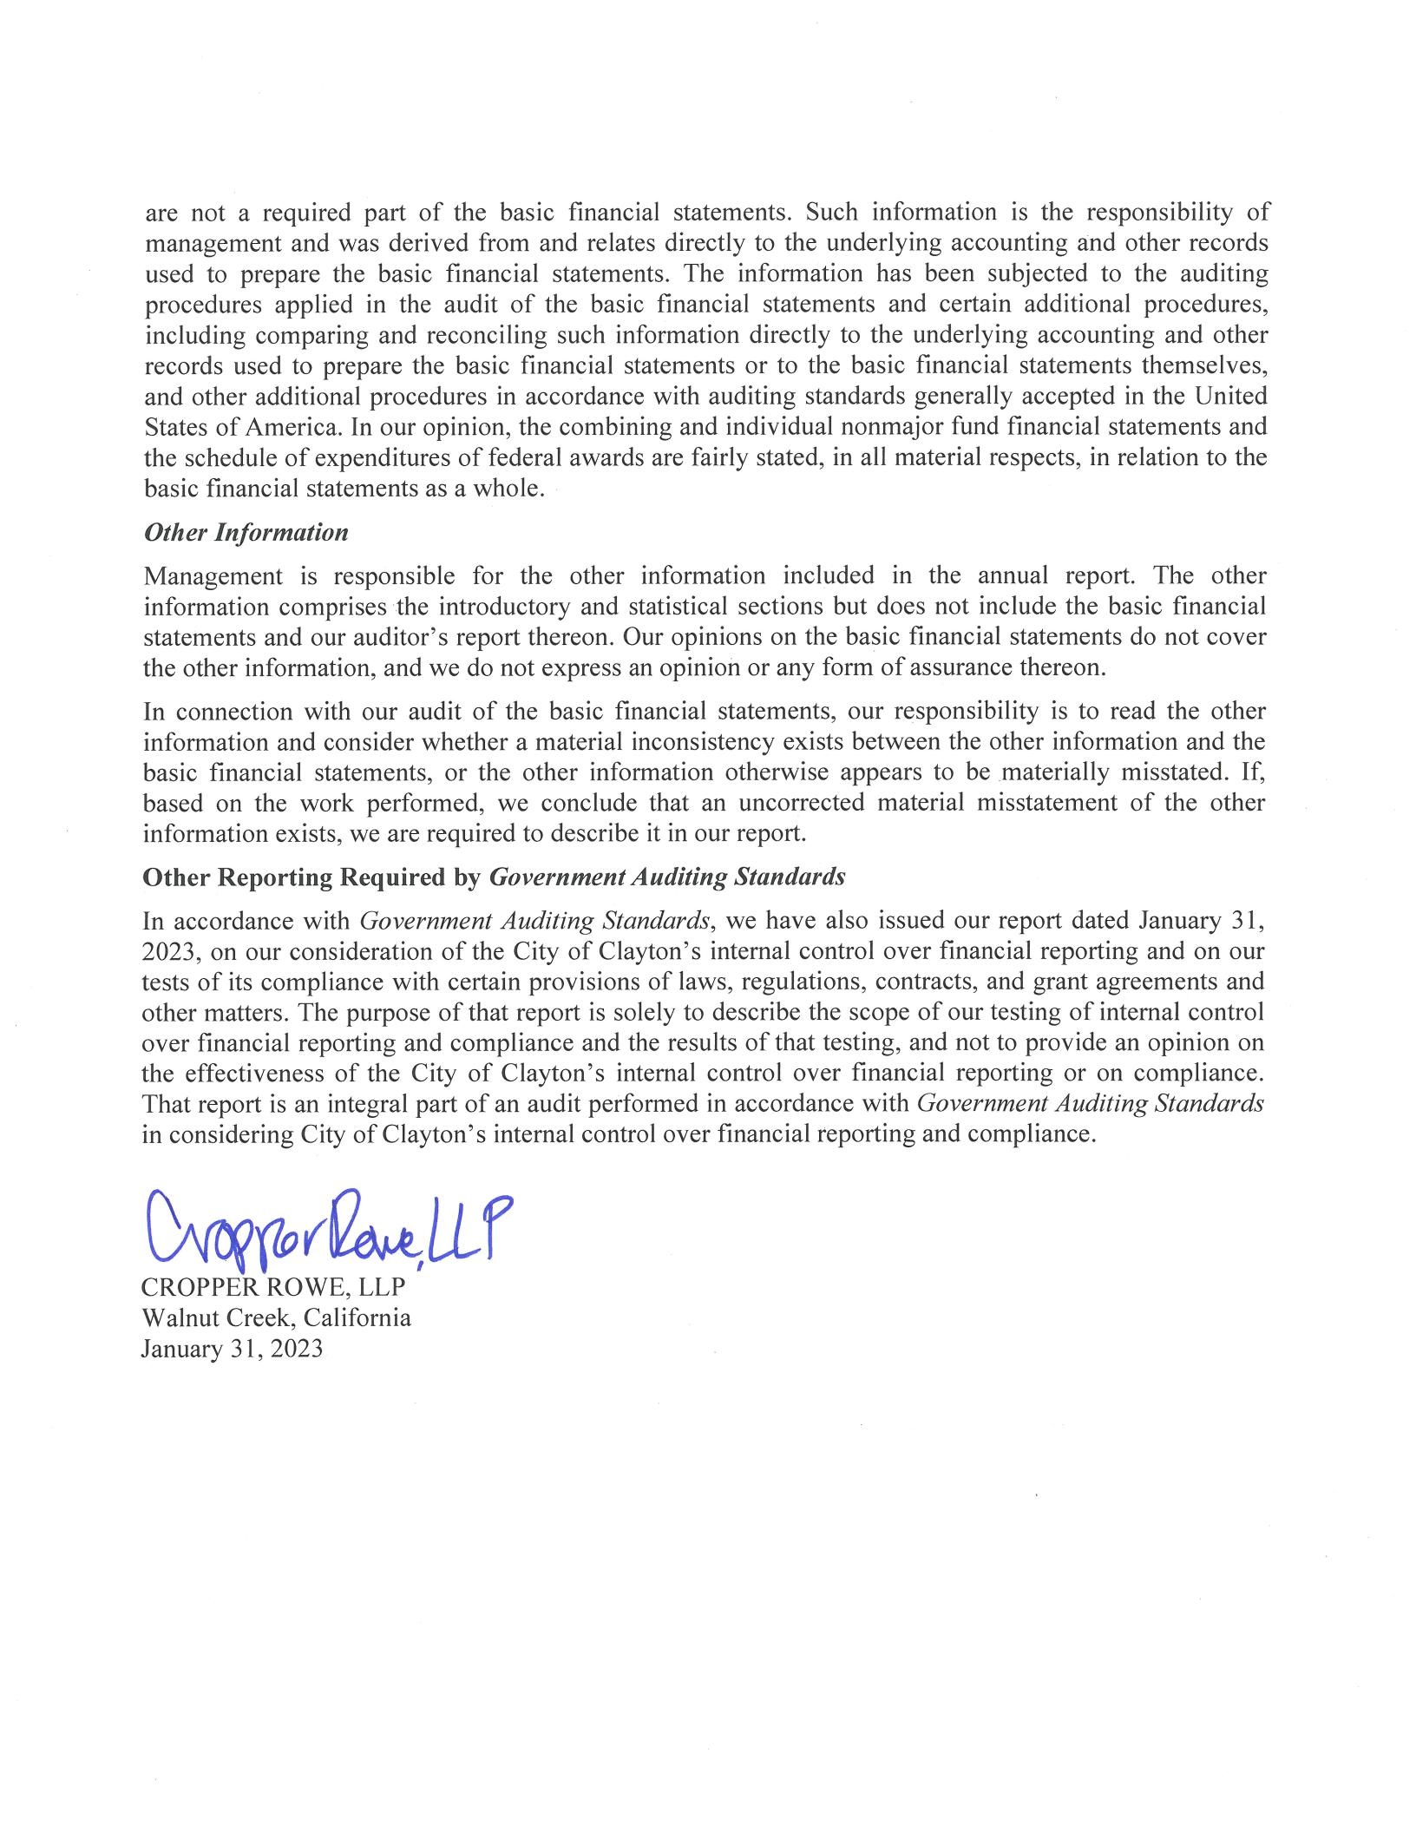

19

MANAGEMENT’S DISCUSSION AND ANALYSIS

20

Management of the City of Clayton (the "City") provides this Management’s Discussion and Analysis of the City's Basic Financial Statements for readers of the City's financial statements. This narrative overview and analysis of the financial activities of the City is for its fiscal year ended June 30, 2022. We encourage readers to consider this information in conjunction with the additional information that is furnished with the City's financial statements, which follow.

FINANCIAL HIGHLIGHTS - PRIMARY GOVERNMENT Government -Wide Highlights

Net Position - The assets of the City of Clayton exceeded its liabilities at the close of the year ended June 30, 2022, by $45,759,874. Of this amount, $5,744,418 was reported as "unrestricted net position" and may be used to meet the ongoing obligations to citizens and creditors.

Changes in Net Position - The City's total net position increased by $337,870 in the fiscal year ending June 30, 2022. Net position of governmental activities increased by $381,717, while net position of business-type activities decreased by $43,847.

Major Fund Highlights

Governmental Funds – As of the year ended June 30, 2022, the City's governmental funds reported a combined ending fund balance of $17,172,907. Of this amount $5,744,867 represents "unassigned fund balances" available for appropriation.

General Fund - The unassigned fund balance of the General Fund on June 30, 2022 was $5,744,867, while the non-spendable and committed fund balances were $173,471 and $495,019 respectively.

OVERVIEW OF THE FINANCIAL STATEMENTS

This discussion and analysis is intended to serve as an introduction to the City of Clayton's basic financial statements. The City of Clayton's basic financial statements comprise three components: 1) government-wide financial statements, 2) fund financial statements and 3) notes to the financial statements. This report also contains required supplementary information and supplemental information in addition to the basic financial statements themselves.

Government-wide Financial Statements

The government-wide financial statements are designed to provide readers with a broad overview of the City of Clayton's finances, in a manner similar to a private-sector business.

The statement of net position presents information on all of the City of Clayton's assets and liabilities, with the difference between the two reported as net position. Over time, increases or decreases in net position may serve as a useful indicator of whether the financial position of the City of Clayton is improving or deteriorating.

21

OVERVIEW OF THE FINANCIAL STATEMENTS, Continued Government-wide Financial Statements, Continued

The statement of activities presents information showing how the City's net position changed during the most recent fiscal year. All changes in net position are reported as soon as the underlying event giving rise to the change occurs, regardless of the timing of related cash flows. Thus, revenues and expenses are reported in this statement for some items that will only result in cash flows in future fiscal periods (e. g. uncollected taxes and earned but unused vacation leave).

Both of the government-wide financial statements distinguish functions of the City of Clayton that are principally supported by taxes and intergovernmental revenues (governmental activities) from other functions that are intended to recover all or a significant portion of their costs through user fees and charges (business-type activities). The governmental activities of the City of Clayton include general government, public safety, public works, community and economic development, and parks and recreation services. The business-type activities of the City of Clayton include the activities of the Endeavor Hall enterprise fund.

Fund Financial Statements

A fund is a grouping of related accounts that is used to maintain control over resources that have been segregated for specific activities or objectives. The City of Clayton, like other state and local governments, uses fund accounting to ensure and demonstrate compliance with finance-related legal requirements. All of the funds of the City of Clayton can be divided into three categories: governmental funds, proprietary funds, and fiduciary funds.

Governmental Funds

Governmental funds are used to account for essentially the same functions reported as governmental activities in the government-wide financial statements. However, unlike the government-wide financial statements, governmental fund financial statements focus on near-term inflows and outflows of spendable resources, as well as on balances of spendable resources available at the end of the fiscal year. Such information may be useful in evaluating a government's near-term financing requirements.

Because the focus of governmental funds is narrower than that of the government-wide financial statements, it is useful to compare the information presented for governmental funds with similar information presented for governmental activities in the government- wide financial statements. By doing so, readers may better understand the long- term impact of the government's near-term financing decisions. Both the governmental fund balance sheet and the governmental fund statement of revenues, expenditures, and changes in fund balances provide a reconciliation to facilitate this comparison between governmental funds and governmental activities.

22

OVERVIEW OF THE FINANCIAL STATEMENTS, Continued Fund Financial Statements, Continued

The City of Clayton maintains fifteen individual governmental funds. Information is presented separately in the government funds balance sheet and governmental funds statement of revenues, expenditures, and changes in fund balances for the General Fund, Landscape Maintenance District, Housing Successor Agency, and Capital Improvement Program, all of which are reported as major funds.

Proprietary Funds

The City of Clayton maintains two different types of proprietary funds. Enterprise funds are used to report the same functions presented as business-type activities in the government- wide financial statements. The City of Clayton uses an enterprise fund to account for its Endeavor Hall activities. Internal service funds are an accounting device used to accumulate and allocate costs internally among the City of Clayton various functions. City of Clayton uses three internal service funds to account for its capital equipment replacement program, self-insurance activities, and extraordinary employer pension contribution fluctuations. Because these services predominantly benefit governmental rather that business-type functions, they have been included within governmental activities in the government-wide financial statements.

Proprietary funds provide the same type of information as the government-wide financial statements, only in more detail. The City’s sole enterprise fund is considered to be a major fund. The internal service funds are combined into a single, aggregated presentation in the proprietary fund financial statements.

Fiduciary Funds

The City is the fiscal agent for benefit assessment districts and other parties holding amounts collected which await payment as directed. The City’s fiduciary activities are reported in the separate statement of fiduciary net position and the agency funds statement of assets and liabilities. These activities are excluded from the City’s other financial statements because the City is acting as a trustee for these funds and cannot use these assets to finance its own operations. The City’s fiduciary funds include a private-purpose trust fund to account for the activities of the City of Clayton Redevelopment Successor Agency.

Notes to the Financial Statements

The notes provide additional information that is essential to a full understanding of the data provided in the government -wide and fund financial statements. The notes to the financial statements can be found on pages 55-101 of this report.

23

OVERVIEW OF THE FINANCIAL STATEMENTS, Continued Other Information

In addition to the basic financial statements and accompanying notes, this report also presents certain required supplementary information concerning the City’s progress in funding its obligation to provide pension and other post -employment benefits to its employees as well as budgetary information for the General Fund and each of the major governmental funds.

FINANCIAL ANALYSIS GOVERNMENT-WIDE STATEMENTS Analysis of Overall Net Position and Results of Operations

As noted previously, net position may serve over time as a useful indicator of a government's financial position. The City’s total net position was $45,759,874 at June 30, 2022, which is an increase of $392,782 from the prior year’s restated net position at June 30, 2021.

The largest portion of the City’s net position reflects its investment in capital assets (e. g. land, buildings, etc. ) net of any related debt used to acquire those assets that is still outstanding. The City uses these capital assets to provide services to citizens and these assets are not available for future spending. Although the City’s investment in its capital assets is reported net of related debt, it should be noted that the resources needed to repay this debt must be provided from other sources, since the capital assets themselves cannot be used to liquidate these liabilities. The following is condensed comparative Statements of Net Position for the fiscal years ended June 30, 2022 and June 30, 2021:

 |  |  |  |  |  |  | Business- |  |  |  | Business-
 | Governmental |  |  | Governmental |  |  |  | Type |  |  | Type
 |  | Activities |  |  | Activities |  | Activities |  |  |  | Activities |  |  | Total |  |  | Total
Assets |  | 2022 |  |  | 2021 |  |  | 2022 |  |  | 2021 |  |  | 2022 |  |  | 2021
Current Assets | $ | 14,773,722 |  | $ | 14,812,813 |  | $ | (120,893) |  | $ | (112,174) |  | $ | 14,652,829 |  | $ | 14,700,639
Noncurrent Assets |  | 6,482,003 |  |  | 6,462,021 |  |  | - |  |  | - |  |  | 6,482,003 |  |  | 6,462,021
Capital Assets |  | 29,116,205 |  |  | 28,793,685 |  |  | 1,009,203 |  |  | 1,038,076 |  |  | 30,125,408 |  |  | 29,831,761
Total Assets
 |  | 50,371,930 |  |  | 50,068,519 |  |  | 888,310 |  |  | 925,902 |  |  | 51,260,240 |  |  | 50,994,421
Deferred outflows |  | 1,285,641 |  |  | 1,051,589 |  |  | - |  |  | - |  |  | 1,285,641 |  |  | 1,051,589
Liabilities
Current Liabilities |  | 640,113 |  |  | 362,937 |  |  | 8,171 |  |  | 1,916 |  |  | 648,284 |  |  | 364,853
Noncurrent Liabilities |  | 3,666,339 |  |  | 5,944,104 |  |  | - |  |  | - |  |  | 3,666,339 |  |  | 5,944,104
Total Liabilities
 |  | 4,306,452 |  |  | 6,307,041 |  |  | 8,171 |  |  | 1,916 |  |  | 4,314,623 |  |  | 6,308,957
Deferred inflows |  | 2,471,384 |  |  | 369,961 |  |  | - |  |  | - |  |  | 2,471,384 |  |  | 369,961
Net Position
Net investment in
capital assets |  | 29,116,205 |  |  | 28,793,685 |  |  | 1,009,203 |  |  | 1,038,076 |  |  | 30,125,408 |  |  | 29,831,761
Restricted |  | 9,890,048 |  |  | 13,156,670 |  |  | - |  |  | - |  |  | 9,890,048 |  |  | 13,156,670
Unrestricted |  | 5,873,482 |  |  | 2,492,751 |  |  | (129,064) |  |  | (114,090) |  |  | 5,744,418 |  |  | 2,378,661
Total net position
 | $ | 44,879,735 |  | $ | 44,443,106 |  | $ | 880,139 |  | $ | 923,986 |  | $ | 45,759,874 |  | $ | 45,367,092

24

FINANCIAL ANALYSIS GOVERNMENT-WIDE STATEMENTS, Continued Analysis of Overall Net Position and Results of Operations, Continued

Of the City’s total net position, $9,890,048 (21.6%) represents resources that are subject to external restrictions on how they may be used. The balance of the unrestricted net position of $5,744,418 (12.6%) may be used to meet the City's ongoing obligations to citizens and creditors. City revenues for the year, including both governmental and business-type activities, were $9,359,704, while expenses totaled $9,021,834, resulting in a net increase in net position of $337,870 excluding transfers, extraordinary and special items. This net increase was primarily attributable to a increase in net position of governmental activities, which is discussed in greater detail in the following section.

The following is a recap of the City’s Statement of Activities and Changes in Net Position for the fiscal years ended June 30, 2022 and June 30, 2021:

 |  |  |  |  |  |  |  |  | Business- |  |  | Business-
 | Governmental |  |  | Governmental |  |  |  |  | Type |  |  | Type
 |  | Activities |  |  |  | Activities |  |  | Activities |  |  | Activities |  |  | Total |  |  | Total
Revenues: |  | 2022 |  |  |  | 2021 |  |  | 2022 |  |  | 2021 |  |  | 2022 |  |  | 2021
Program revenues:
Charges for Services | $ | 1,002,338 |  | $ |  | 961,910 |  | $ | 16,847 |  | $ | (1,442) |  | $ | 1,019,185 |  | $ | 960,468
Operating grants and contributions |  | 2,755,382 |  |  |  | 893,718 |  |  | - |  |  | - |  |  | 2,755,382 |  |  | 893,718
Capital grants and contributions |  | 120,774 |  |  |  | 42,363 |  |  | - |  |  | - |  |  | 120,774 |  |  | 42,363
Total program revenues
 |  | 3,878,494 |  |  |  | 1,897,991 |  |  | 16,847 |  |  | (1,442) |  |  | 3,895,341 |  |  | 1,896,549
General revenues:
Property taxes |  | 2,846,766 |  |  |  | 2,722,906 |  |  | - |  |  | - |  |  | 2,846,766 |  |  | 2,722,906
Special parcel taxes |  | 1,348,657 |  |  |  | 1,309,373 |  |  | - |  |  | - |  |  | 1,348,657 |  |  | 1,309,373
Sales and use taxes |  | 563,908 |  |  |  | 510,029 |  |  | - |  |  | - |  |  | 563,908 |  |  | 510,029
Business license taxes |  | 162,881 |  |  |  | 90,872 |  |  | - |  |  | - |  |  | 162,881 |  |  | 90,872
Franchise fees |  | 587,740 |  |  |  | 567,350 |  |  | - |  |  | - |  |  | 587,740 |  |  | 567,350
Payments in lieu of taxes |  | 174,443 |  |  |  | 171,029 |  |  | - |  |  | - |  |  | 174,443 |  |  | 171,029
Investment income |  | (281,502) |  |  |  | 508,256 |  |  |  |  |  | (379) |  |  | (281,502) |  |  | 507,877
Miscellaneous |  | 54,512 |  |  |  | 38,972 |  |  | - |  |  | - |  |  | 54,512 |  |  | 38,972
Gain (loss) on sale of assets |  | 6,958 |  |  |  | 1,741 |  |  | - |  |  | - |  |  | 6,958 |  |  | 1,741
Total general revenues
 |  | 5,464,363 |  |  |  | 5,920,528 |  |  |  |  |  | (379) |  |  | 5,464,363 |  |  | 5,920,149
Total revenues
 |  | 9,342,857 |  |  |  | 7,818,519 |  |  | 16,847 |  |  | (1,821) |  |  | 9,359,704 |  |  | 7,816,698
Expenses:
General government |  | 2,629,048 |  |  |  | 1,796,454 |  |  | - |  |  | - |  |  | 2,629,048 |  |  | 1,796,454
Public works |  | 2,509,096 |  |  |  | 2,909,710 |  |  | - |  |  | - |  |  | 2,509,096 |  |  | 2,909,710
Public safety |  | 2,736,817 |  |  |  | 2,980,000 |  |  | - |  |  | - |  |  | 2,736,817 |  |  | 2,980,000
Community and economic
development |  | 356,450 |  |  |  | 357,133 |  |  | - |  |  | - |  |  | 356,450 |  |  | 357,133
Parks and recreation services |  | 729,729 |  |  |  | 592,433 |  |  | - |  |  | - |  |  | 729,729 |  |  | 592,433
Endeavor Hall |  | - |  |  |  | - |  |  | 60,694 |  |  | 73,117 |  |  | 60,694 |  |  | 73,117
Total expenses
 |  | 8,961,140 |  |  |  | 8,635,730 |  |  | 60,694 |  |  | 73,117 |  |  | 9,021,834 |  |  | 8,708,847
Change in Net Position |  | 381,717 |  |  |  | (817,211) |  |  | (43,847) |  |  | (74,938) |  |  | 337,870 |  |  | (892,149)
Net Position – Beginning, restated
 |  | 44,498,018 |  |  |  | 45,260,317 |  |  | 923,986 |  |  | 998,924 |  |  | 45,422,004 |  |  | 46,259,241
Net Position – ending
 | $ | 44,879,735 |  |  | $ | 44,443,106 |  | $ | 880,139 |  | $ | 923,986 |  | $ | 45,759,874 |  | $ | 45,367,092

25

FINANCIAL ANALYSIS GOVERNMENT-WIDE STATEMENTS, Continued Analysis of Governmental Activities

The increase in net position of the governmental activities over the prior year was primarily attributable to a increase in both operating and capital grants and contributions. Total expenses were $8,961,140 in the current year compared to $8,635,730 in the prior year. The following chart depicts the relative size of expenses by function for the fiscal years ending June 30, 2022 and 2021:
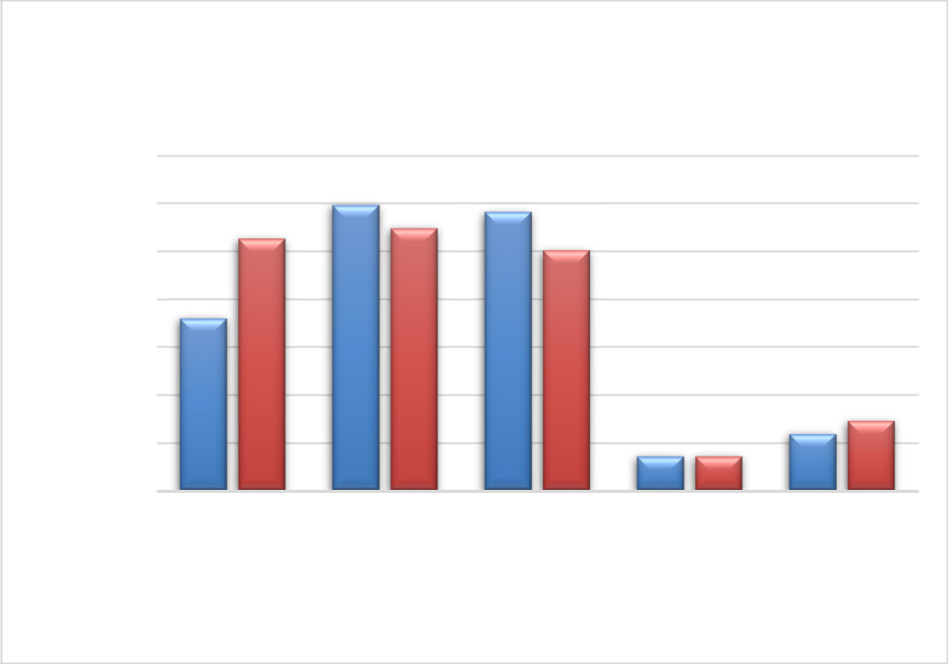

Government Activities

Expenses by Function

3,500,000

3,000,000

2,500,000

2,000,000

1,500,000

1,000,000

500,000

-

General
Government

Public Safety

Public Works Community Parks and
and Economic Recreation

Development Services

Fiscal Year 2021

Fiscal Year 2022

Total program revenues from governmental activities were $ 3,878,494 in the current year compared to $1,897,991 in the prior year. Program revenues are derived directly from the program itself or from parties outside the reporting government's taxpayers or citizenry. They reduce the net cost of the function to be financed from government's general revenues. Of the governmental program revenues, 25.8% were derived from charges for services, which includes park use fees, rental fees, licenses and permits, planning services fees, engineering plan check fees, police service fees, and other revenues. The remaining 74.2% of the governmental program revenues came from operating and capital grants and contributions. General revenues are all other revenues not categorized as program revenues such as property taxes, special parcel taxes, sales and use taxes, motor vehicle fees, investment earnings, franchise fees, use of money and property, service charges, and miscellaneous revenues.

26

FINANCIAL ANALYSIS GOVERNMENT-WIDE STATEMENTS, Continued Analysis of Governmental Activities, Continued
Total general revenues from governmental activities decreased by $456,165 (7.7%) over the prior year. The following pie charts depict the relative size of governmental activities program and general revenues by source for the fiscal years ending June 30, 2022 and 2021:
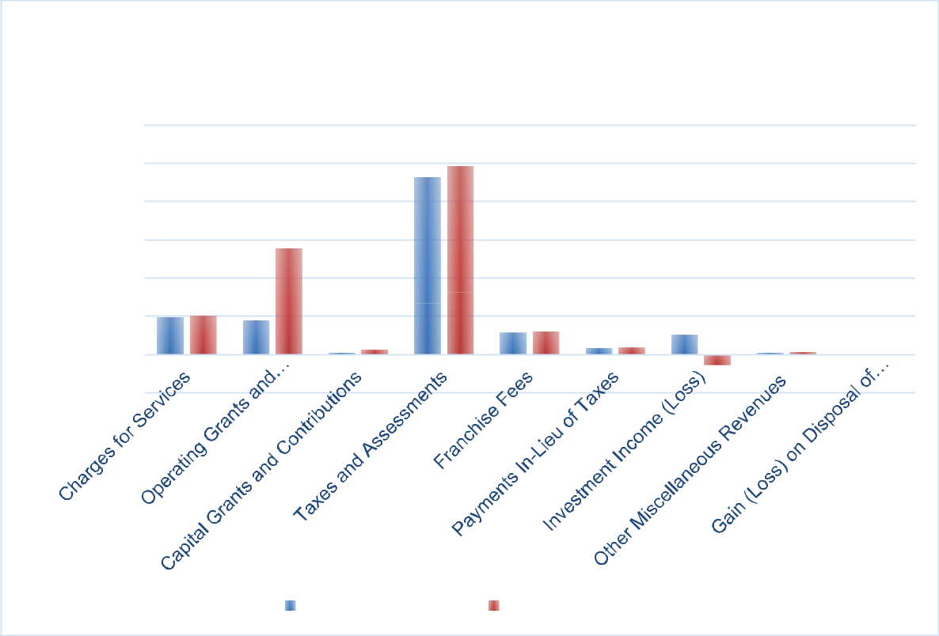

Governmental Activities
Revenues by Source
$6,000,000
$5,000,000
$4,000,000
$3,000,000
$2,000,000
$1,000,000
$-
$(1,000,000)
Fiscal Year 2021 | Fiscal Year 2022

Analysis of Business-Type Activities

Total business-type expenses decreased 20.4% from $73,117 in the prior year to $60,694 in the current year. This decrease is largely attributable to the decrease in general and administrative costs of the Endeavor Hall rental facility. Total services revenue increased significantly from $-1,442 in the prior year to $16,847 in the current year due to the increase in rental activity. Net position of business -type activities declined $43,847 to a total of $ 880,139 at June 30, 2022 due to charges for services being insufficient to cover the annual depreciation expense and general operating expenses of underlying Endeavor Hall rental facility assets.

27

FINANCIAL ANALYSIS OF INDIVIDUAL FUND STATEMENTS Analysis of Governmental Funds

The focus of the City of Clayton's governmental funds is to provide information on near-term inflows, outflows, and balances of spendable resources. Such information is useful in assessing the City of Clayton's financing requirements. In particular, unassigned fund balance may serve as a useful measure of a government's net resources available for spending at the end of the fiscal year.

As of the end of the current fiscal year, the City’s governmental funds reported combined ending fund balances of $17,172,907. Of this amount, $5,744,867 (33.5%) is unassigned; $173,471(1.0%) is in non-spendable form; $3,330,153 (19.4%) is assigned for specific purposes; $6,719,595 (39.1%) is restricted by law, regulation, or other outside contractual agreements; and $1,204,821 (7.0%) is committed for specific expenditures in the future.

General Fund

The City’s General Fund reported an increase in fund balance of $249,464 (4.0%) in the current fiscal year. This modest increase is mostly attributable to increase in property taxes, special parcel taxes and assessments, and a corresponding decrease in investment earnings (primarily due to market rate adjustments). Total fund balance of the General Fund is $6,413,357 as of June 30, 2022, of which $5,744,867 (89.6%) is reported as unassigned and available for appropriation. This unassigned fund balance is .92 times the size of the General Fund’s adopted operating budget for the upcoming fiscal year ending June 30, 2022.

Below is a summary of the General Fund expenditures by department.

 |  |  |  |  |  |  |  | Pandemic
 |  |  |  |  | Rainy |  |  | Recovery
General government | General Fund |  |  |  | Day Fund |  |  | Reserve |  |  | Total
 | $ | 1,447,700 |  | $ | 26,000 |  | $ | 1,096,717 |  | $ | 2,570,417
Public safety |  | 2,684,319 |  |  | - |  |  | - |  |  | 2,684,319
Public works |  | 333,423 |  |  | - |  |  | - |  |  | 333,423
Community and
economic development |  | 299,175 |  |  | - |  |  | - |  |  | 299,175
Parks and recreation
services |  | 336,592 |  |  | - |  |  | - |  |  | 336,592
Capital outlay |  | 22,168 |  |  | - |  |  | - |  |  | 22,168
Total expenditures | $ | 5,123,377 |  | $ | 26,000 |  | $ | 1,096,717 |  | $ | 6,246,094

Landscape Maintenance District

Community Facilities District No. 2007-1, referred to as the Landscape Maintenance District special revenue fund, reported a decrease in fund balance of $447,353 (41.2%) in the current fiscal year. This decrease in fund balance is largely attributable to increases in operating costs such as water service and weed abatement, as well as a increase in project costs/capital outlay costs. Total fund balance of the Landscape Maintenance District is $ 638,533 as of June 30, 2022, of which $ 32,509 is reported as assigned or restricted for the following year’s operating budget, and the remaining fund balance is assigned.

28

FINANCIAL ANALYSIS OF INDIVIDUAL FUND STATEMENTS, Continued Analysis of Governmental Funds, Continued
Successor Housing Agency

The Successor Housing Agency special revenue fund reported a increase in fund balance of $187,452 (3.4%) in the current fiscal year. This increase in fund balance resulted primarily from unspent program revenue on housing loan repayments as well as unrealized gains on the inventory of affordable income housing. Total fund balance of the Successor Housing Agency is $5,617,695 as of June 30, 2022, which is classified entirely as restricted.

Capital Improvement Program

The Capital Improvement Program capital projects fund reported an increase in fund balance of $681,698 (35.4%) in the current fiscal year. This increase in fund balance primarily arose from timing differences between project execution and funding. Total fund balance of the Capital Improvement Program fund is $2,606,444 and is reported entirely as assigned for capital projects as of June 30, 2022.

Analysis of Proprietary Funds

The City of Clayton's proprietary funds provide the same type of information found in the government-wide financial statements, but in more detail. The net position of the City’s only major enterprise fund, Endeavor Hall, at the end of the year was $880,139, and total net position for the internal service funds amounted to $1,000,736.

GENERAL FUND BUDGETARY HIGHLIGHTS

General Fund actual revenues and transfers fall short of total revenues and transfers of the final and adopted budget by $39,744. The variance is due to a combination of factors including an increase in taxes and assessment and a decrease in the investment reported at year-end based on the market rate. The unrealized investment loss was reported as a direct result of the City’s investment portfolio being largely made up of fixed instrument securities during a time of declining interest rates. As noted in recent quarterly investment portfolio reports presented to the City Council, the City’s investment policy is designed to reduce volatility and generate consistent returns in the long run-in order to protect public funds. Actual property tax revenues exceeded somewhat conservative adopted budgetary growth projections by $186,163 (6.9%), which was largely offset by lower-than-expected revenue from permits, licenses and fees and sales tax receipts.

29

GENERAL FUND BUDGETARY HIGHLIGHTS, Continued

Actual General Fund expenditures of $6,246,094 were more than the final adjusted budget by $1,447,307 for the year ended June 30, 2022. The negative variance is a result of actual expenditures being more than budgeted in General government due to investments in the capital expenditures for the fiscal year ended June 30, 2022.

CAPITAL ASSET AND DEBT ADMINISTRATION Capital Assets
The City’s investment in capital assets for its governmental and business-type activities as of June 30, 2022 amounted to $30,125,408 (net of accumulated depreciation). This investment in capital assets includes land, building, improvements, machinery and equipment, park facilities, corporate yard building, and roads. Total depreciation expense on governmental assets totaled $1,048,171, versus $1,080,713 in the prior year. The slight decrease in depreciation is attributable to the completion of significant capital projects during the prior and current fiscal years and capital assets reaching their estimated useful lives. Additional information on the City of Clayton's capital assets can be found in Note 6 of this report.

Debt Administration

The remaining debt of the former Clayton Redevelopment Agency (RDA) of $ 5,835,000 was transferred to the Successor Agency on February 1, 2012 (fiscal year ending June 30, 2012) . The City has no outstanding general obligation debt. The Successor Agency has maintained its "AAA" credit rating (S&P) on outstanding Tax Allocation Bonds. Additional information on the Successor Agency's long-term debt can be found in Note 13 of this report.

ECONOMIC FACTORS AND NEXT YEAR’S BUDGET

As the City of Clayton is largely a residential community the annual General Fund operating budget relies heavily on property taxes to finance annual operating appropriations rather than other sources of revenue larger and more commercially and industrial developed municipalities have access to (i. e. sales and transient occupancy taxes). The City strives to meet the ever evolving needs of local residents and businesses within the constraints of limited and sometimes restrictive revenue sources.

There was an increase in adopted General Fund operating appropriations when compared to the actuals reported as of June 30, 2022, for the upcoming fiscal year ending June 30, 2023 of $641,365 (10.2%) . The increase in appropriations is attributable primarily to labor wage and benefit costs of various City departments and capital improvement costs included as part of the general government. The annual June 2021 to June 2022 consumer price index inflationary factor is 6.8% as published by the U. S. Bureau of Labor and Statistics for the San Francisco-Oakland-Hayward region. In addition, there are projected decreases in the annual CalPERS unfunded accrued liabilities and normal costs, primarily due to Classic Tier employees retiring and new employees being hired in the PEPRA tier. The adopted budget for the fiscal year ending June 30, 2023 projects total General Fund revenues of $6,887,459 an increase of approximately

30

City of Clayton

Management’s Discussion and Analysis
For the year ended June 30, 2022

ECONOMIC FACTORS AND NEXT YEAR’S BUDGET, Continued

$34,920 over the prior year actual. The projected revenue growth reflects continued growth in property tax and sales and use taxes supported by actual results reported in the fiscal year ending June 30, 2022.

REQUEST FOR INFORMATION

This financial report is designed to provide a general overview of the City of Clayton's finances for all those with an interest in the City's finances. Questions concerning any of the information provided in this report, or requests for additional financial information, should be addressed to the Office of the Finance Manager, 6000 Heritage Trail, Clayton, California 94517.

31

GOVERNMENT-WIDE

FINANCIAL STATEMENTS

32

